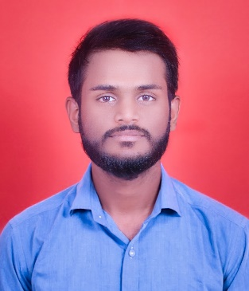

# CONTACT

### PHONE:

8669102918

### EMAIL:

mayureshdurgade@gmail.com

### LINKEDIN:

https://www.linkedin.com/in/mayuresh-durgade-1765b2247

### GITHUB:

### https://github.com/mayureshdurgade

# OBJECTIVE

To obtain a challenging position in a Software Engineering environment where my resourceful knowledge and academic skills will add value to organizational operations.

# PERSONAL DETAILS

DOB: 13 July 2002

Nationality: Indian Address: At post Walhe

Tal - Purandar,

Dist - Pune (412 305)

# HOBBIES

* Programing
* Swimming
* Reading Books
* Playing

# LANGUAGES

* English
* Hindi
* Marathi

# COURSE WORK

* Data Structure & Algorithms
* Object Oriented Programing
* Operating System
* Database : Relational Database

MAYURESH SANDIP DURGADE

## EDUCATION

#### Savitribai Phule Pune University.

**Sharadchandra Pawar College of Engineering and Technology, Someshwarnagar.**

TE Computer (Pursuing)

Sem 5:- 6.43 (sgpa)

SE Computer

9.14 (sgpa)

FE Computer

7.93 (sgpa)

#### Waghire College, Saswad.

HSC Examination (55.54%)

**Maharshi Walmiki Vidyalaya, Walhe**

SSC Examination (69.80%)

## KEY PROJECTS

#### Note making Website

Languages- HTML, CSS, JS

#### Portfolio Website

Languages- HTML, CSS, JS, BOOTSTRAP

#### Personal blog website

Languages- HTML, CSS, JS

## TECHNICAL SKILLS

* C
* C++
* Python
* HTML
* CSS
* JAVA

## CERTIFICATIONS

* Become a Full-Stack Web Developer Linkedln Certificate.
* Certificate in Python.

## DECLARATION

I hereby declare the above information is correct to the best of my knowledge and I bear the full responsibility for the correctness of the above-mentioned particular’s.